Project 2: Taylor’s Economic Controversy

MSBC 5030 – Quantitative Methods

University of Colorado – Boulder

Rachel Bauer, Michael Gambee, Christine Ottinger, Lakshay Wadhwa, Tyler Chambers

**Analyzing Taylor’s Proposed Correlation (Question 4)**

Taylor paints a vivid picture of the harmfulness of government expenditure and investment against the unemployment rate. In his graph, reproduced by our team below, we can see that indeed it seems like the two variables are correlated.



Analyzing the correlation between the variables over this 20-year subset from 1990-2010 we get a staggering correlation of .805. Clearly this seems like powerful evidence in support of Taylor’s position, but looking at the full data set from 1947-2018 we get a very different perspective. First, take a look at the unaltered graph of the full dataset.



Here we see a relationship that has a very different, almost bell-curved, outcome that seems to more solidly point at an absence of a relationship between the two variables. In fact, the lowest unemployment variables seem to result from times of highest government expenditures! That being said, we see quite low employment as well from times of relatively low government expenditure. Coloring the points by decade and looking at decade correlations gives us further insights.

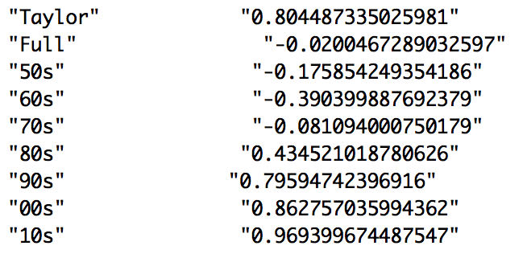



Certain decades, like the 2010’s for example, follow Taylor’s relationship very nicely, looking almost perfectly positively related. However, decades like 1970’s seem to almost show no relationship, if not a slightly negative one. Finally, decades like the 1950’s show a fully negative relationship. Based on this, it would appear that the relationship seems to be more of a product of what else is happening at the time than that of a pure relationship between government expenditure and unemployment rate. Take a look at some regressions also plotted by decade.



Here we can observe during the 1950’s through the 1970’s negative relationships between unemployment rate and government spending are occurring. Conversely the 1980’s through 2010’s show more positive correlations. To me this split in the data shows that more intervening factors seem to control the relationship. The Cold War spending of the 1950’s-70’s seems to have been “positive”, while more recent spending seems to not have had the same impact. It is also worth noting that the strongest negative correlations stem from a low-end expenditure around 20% of GDP, while the strongest positive correlations seem to be more powerful the lower they start as a percentage of GDP. Our point is that more than anything, this graph seems to point to the fact that approx. 22% is just a bad spot for government spending to be at. Both lower and higher levels of spending seem to perform better that that middling rate. Perhaps more concentrated economic policies on both sides are more effective for fighting unemployment, while middling efforts fail. It is hard to conjecture without a strong economics background, but the fact remains: Taylor’s point is not substantiated enough without explaining these negative correlations throughout the 1950’s-1970’s.

**Using Code to Cherry Pick our own data (Question 5)**

In our quest to cherry pick correlations from random variable pairs, we were able to glean some more insights into Taylor’s approach. By simulating draws from a normally distributed population centered around 5 with a standard deviation of 10 for x and y, we were able to get a virtually uncorrelated data set, as well as a weakly correlated data set. Below is our graph of correlations for the full simulated 256 quarters, pulled 1000 times.



We can see that it is centered almost fully on 0 and featured a small spread that barely makes is to .2 on both the positive and negative sides. Our cherry-picked values, where we grabbed the maximum correlation we could find iterated from 60 quarters up to 256 quarters, repeated 1000 times, shows a different distribution.



We can see that this population is more centered around .08 and featured a right skew and larger overall spread. Our two-sample t-test and matched-pairs t-test both reject the null hypothesis that the correlation populations are the same. 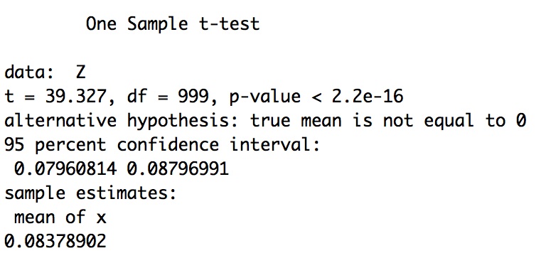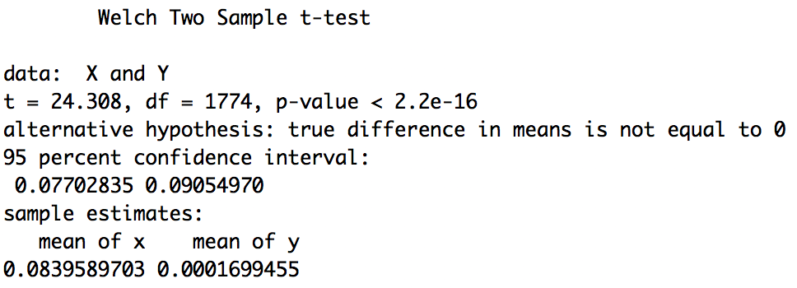

Finally, we ran a t-test to see if Taylor’s cherry-picked value could have been generated form our totally random code (shown below). While Taylor's value is cherry picked, it could not be generated from this totally random value set of cherry picked values. Our maximum cherry-picked correlation was only able to reach .4166832 under the total randomness, this just wasn't enough variability to reach Taylor's over .8 positive correlation. To me this shows that Taylor wasn’t observing a totally random interaction, but rather, a much more complicated one with many intervening factors.

